
IO List and Schematics of the Emotibot
Team IT-1B

2026-06-12

This document shows the inputs and outputs of the components used in the project innovate EmotiBot.

Input
Front ultrasonic sensor
Echo pin → Digital IO 12
Right ultrasonic sensor
Echo pin → Digital IO 10
Back ultrasonic sensor
Echo pin → Digital IO 13
Left ultrasonic sensor
Echo pin → Digital IO 11

AdaFruit
Audio In+ → Pin 12
Audio In- → Pin 14

Output

Motor
Motor pin LPWM 1 → Digital IO (~PWM) 9 (Left motor reverse direction)
Motor pin RPWM 1→ Digital IO (~PWM) 6 (Left motor forward direction)
Motor pin LWPM 2 → Digital IO (~PWM) 5 (Right motor reverse direction)
Motor pin RWPM 2 → Digital IO (~PWM) 3 (Right motor forward direction)

Front ultrasonic sensor
Trigger pin → Digital IO 8
Right ultrasonic sensor
Trigger pin → Digital IO 2
Back ultrasonic sensor
Trigger pin → Digital IO 4
Left ultrasonic sensor
Trigger pin → Digital IO 7

AdaFruit
Speaker + → VO+
Speaker - → VO-

GND
- Front ultrasonic sensor
- Right ultrasonic sensor
- Back ultrasonic sensor
- Left ultrasonic sensor
- Right motor driver
- Left motor driver
- AdaFruit

5V
- Front ultrasonic sensor
- Right ultrasonic sensor
- Back ultrasonic sensor
- Left ultrasonic sensor
- Right motor driver
- Left motor driver
- Left motor forward
- Left motor backwards
- AdaFruit

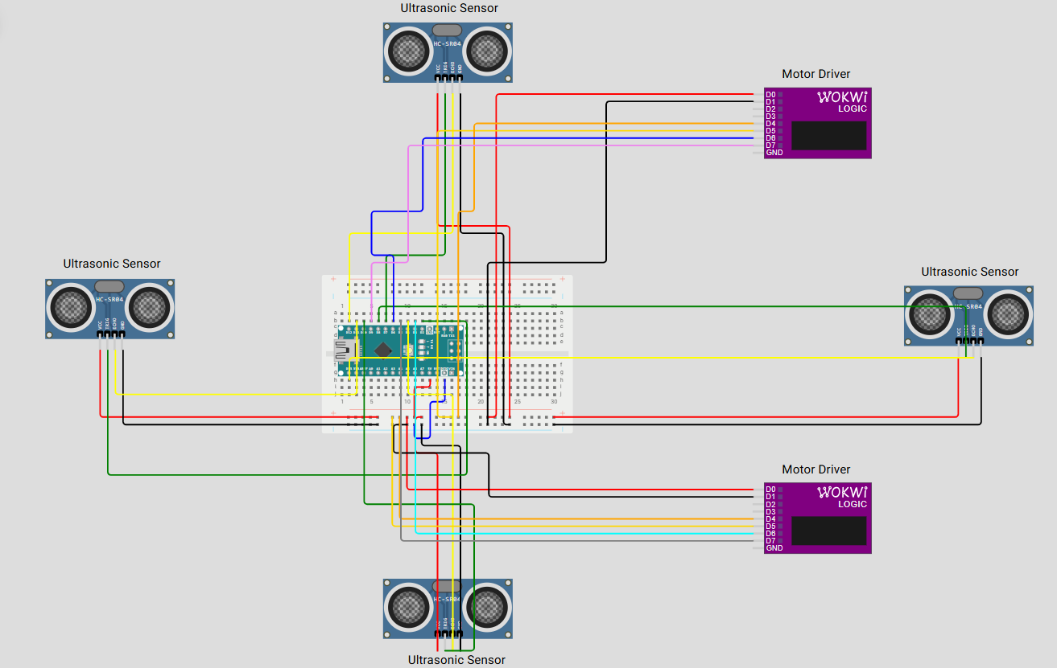
Schematic representation of the Emotibot

